**Software Requirements Specification**

**for**

**<Fitness World>**

**Version 1.0 approved**

**Prepared by <Jaini Rutvik>**

**Prepared by <Gaddam Sri Sai kumar>**

**<Software Engineering CS 301>**

**<05/09/2018>**

**Table of Contents**

**Table of Contents ii**

**Revision History ii**

**1. Introduction 1**

1.1 Purpose 1

1.2 Document Conventions 1

1.3 Intended Audience and Reading Suggestions 1

1.4 Product Scope 1

1.5 References 1

**2. Overall Description 2**

2.1 Product Perspective 2

2.2 Product Functions 2

2.3 User Classes and Characteristics 2

2.4 Operating Environment 2

2.5 Design and Implementation Constraints 2

2.6 User Documentation 2

2.7 Assumptions and Dependencies 3

**3. External Interface Requirements 3**

3.1 User Interfaces 3

3.2 Hardware Interfaces 3

3.3 Software Interfaces 3

3.4 Communications Interfaces 3

**4. System Features 4**

4.1 System Feature 1 4

4.2 System Feature 2 (and so on) 4

**5. Other Nonfunctional Requirements 4**

5.1 Performance Requirements 4

5.2 Safety Requirements 5

5.3 Security Requirements 5

5.4 Software Quality Attributes 5

5.5 Business Rules 5

**6. Other Requirements 5**

**Appendix A: Glossary 5**

**Appendix B: Analysis Models 5**

**Appendix C: To Be Determined List 6**

**Revision History**

|  |  |  |  |
| --- | --- | --- | --- |
| **Name** | **Date** | **Reason For Changes** | **Version** |
|  |  |  |  |
|  |  |  |  |

# Introduction

## 

## Purpose

*Online website for NU students who do gym which helps in managing their gym schedules,workouts and diet plan.*

## Document Conventions

*Bold letters in this document indicate the headings and name of the project and the normal Italic letters indicate the description about them.*

## Intended Audience and Reading Suggestions

*All the personal who are responsible for making the website,developing the website and maintaining the website should read and understand this. The rest of this SRS contains overall details of the website such as user interface,software requirements,security requirements an scope of this website.*

## Product Scope

*Online website FITNESS WORLD is very helpful for NU students who do gym. There are separate schedules especially for beginners. There are video tutorials of the workout. There are a Queries will be answered with in a day so that they will get clarity. Separate diet schedules will be prepared on request of customers according to their body type and body weight. It is also helpful in ordering eggs and chicken from outside as it is costly in the campus.*

## References

*IEEE format for SRS document by Karl E.Wiegers .Copyright © 1999 . Permission is granted to use, modify, and distribute this document.*

# Overall Description

## Product Perspective

*This website aimed towards the students to know the complete details about workouts, diet plans,schedules and to order eggs and chicken with low cost compared in the campus.*

## Product Functions

*This website database consists of following information*

* *Video tutorials of workouts*
* *Workout Schedules*
* *Diet plans*
* *Queries*
* *Place order(eggs and chicken)*

## User Classes and Characteristics:

## *This website consists of the following objects*

1. ***Register Object:*** *This object contains the various details about the user entered during registration.*
2. ***User Object:*** *This object contains the various details entered by the user after login to the application.*
3. ***Diet Chart Object:*** *This object contains various information about the food and the amount to be consumed.*
4. ***Exercise Object:*** *This object contains the various information related to exercises.*
5. ***Motivate Object:*** *This object contains the information about the advantages of healthy lifestyle.*

## Operating Environment

*This software package is expected to work in the following environment*

1. *Microsoft stack consisting of*
2. *Windows10*
3. *HTML, Css, Java Script, Bootstrap.*
4. *MySQL, PHP.*

## Design and Implementation Constraints

1. *All HTML code shall conform to the HTML 8.0 Standard.*
2. *The System shall use the MySQL database engine.*
3. *All scripts shall be written in PHP.*

## User Documentation

*a)This software package will come with a users manual as a guide to its interface actions.*

*b)The details of the Analysis,Design and test cases will be delivered along with this project.*

## Assumptions and Dependencies

*AS-1: This website is open for queries in which admin is expected to be on site.*

*DE-1:The operation of placing order depends on the availability of the items.*

# External Interface Requirements

## User Interfaces

*User Interface – All user interfaces will be created through PHP, Javascript and CSS.*

*PHP will be the main programming language driving the website. Javascript allows portions of web pages to be refreshed without having to reload the entire webpage. One application of this is tabbed browsing within a website.*

*Database Interface – All database interaction will be hidden from the users and will be dynamically handled through the website. If a user requests a report or something then the website will query into the database retrieving the information and displaying it to the user in a user friendly manner.*

## Hardware Interfaces

*There is no Hardware Interfaces identified.*

## Software Interfaces

*Operating System:We have chosen Windows operating system for its best support and user-friendliness*

*Database:To save the records of customers we have chosen MYSQL database.*

## Communications Interfaces

*This project supports all types of web browsers and we use HTTP for communication between user and the server .*

# System Features

|  |  |  |
| --- | --- | --- |
| *Requirement Id* | *Requirement Specifications* | *Priority* |
| *1* | *User Login* | *A* |
| *2* | *View Schedule* | *A* |
| *3* | *View Diet Plan* | *A* |
| *4* | *View Videos* | *A* |
| *5* | *Ask Queries* | *A* |
| *6* | *View Responses* | *A* |
| *7* | *Request Diet Plan* | *B* |

## 

|  |  |  |
| --- | --- | --- |
| *8* | *Request Workout Schedule* | *B* |
| *9* | *Requesting Video Tutorials* | *B* |
| *10* | *Answer Queries* | *A* |
| *11* | *Place Order* | *A* |
| *12* | *Delete Order* | *B* |

## 

|  |  |  |
| --- | --- | --- |
| *13* | *View Order* | *B* |
| *14* | *Add Diet Plans* | *A* |
| *15* | *Add WorkOut Schedules* | *A* |

## 

## User Login

4.1.1 Description and Priority

*This function is handled and updated by the Administrator and user is just able to login into it and other features can’t be seen without logging in All users of the software shall have the ability to create an account which is used to store user data and tie user actions to a user alias. User registration and login shall be mandator So, it stands at a priority labelled ‘A’ which means its having a high priority.*

4.1.2 Stimulus:

*This specific function is performed by user as an action or can be viewed by the user. This function is an action carried out by the administrator User which provides the confirmation into the web application*

Response Sequences:

*It is the function which gives a direct reaction for the user’s action.*

4.1.3 *Functional Requirements*

*REQ-1:A device which has Internet connection.*

*REQ-2:The system should notify the user if submitted information is incorrect.*

*REQ-3:The system should ask the user for their email address and password.*

*REQ-4:User must have a supporting browser.*

## 4.2 Create User

4.2.1 Description and Priority

*The system should provide the user with an easy to use GUI to facilitate their creating an account. The system shall ask for an email address and password.The system shall notify the user if incorrect characters are used in the email or password fields.So, it stands at a priority labelled ‘A’ which means its having a high priority.*

4.2.2 Stimulus:*This specific function is performed by user as an action or can be viewed by the user. This function is an action carried out by the administrator User which provides the confirmation into the web application*

Response Sequences:*It is the function which gives a direct reaction for the user’s action.*

4.2.3 *Functional Requirements*

*REQ-1:A device which has Internet connection.*

*REQ-2:The system should not allow the user to create weak or unsecured passwords.*

*REQ-3:The system should notify the user if their email has already been used.*

*REQ-4:The system should notify the user if any required fields are left empty.*

*REQ-5:User must have a supporting browser.*

## 4.3 Asking Queries

4.3.1 *Description and Priority*

*The system shall provide an interface for asking queries to the admin.And replies are given according to the asked question.So, it stands at a priority labelled ‘A’ which means its having a high priority.*

4.3.2 Stimulus: *This specific function is performed by user as an action or can be viewed by the user. It is the function which gives a direct reaction for the user’s action*

Response Sequences:*The replies to the queries are given by the admin itself and this is a spontaneous process.*

4.3.3 *Functional Requirements*

*REQ-1:A device which is having good Internet connection.*

*REQ-2:A valid query to ask the admin.and the reply for this is given by the admin itself.*

*REQ-3:The person who logins in is able to access this feature*

*REQ-4:User must have a supporting browser.*

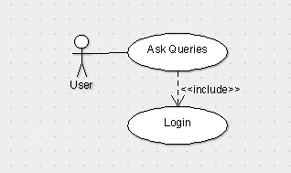

## 4.4 Diet Program

4.4.1 *Description and Priority*

*The system will provide an intuitive and user friendly UI to allow the user to view the personal Diet list.Which is a balanced diet plan and is provided on the request of the user.This feature is managed by the admin and user is just able to view this feature.As it is the important feature So, it stands at a priority labelled ‘A’ which means its having a high priority.*

4.4.2 Stimulus:*This specific function is performed by user and able to be viewed by the user. It is the function which gives a direct reaction for the user’s action.*

Response Sequences*:The response for this is given by the admin, diet plan given in a balanced diet.*

4.4.3 *Functional Requirements*

*REQ-1:The person who logins in is able to access this feature .*

*REQ-2:Person who requires a diet plan can ask the admin.*

*REQ-3: User must have a supporting browser.*

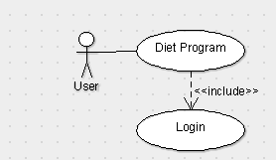

## 4.5 Personal WorkOut Program

4.5.1 *Description and Priority*

*The system will provide a user friendly UI allows the user to ask and manage the personal workout plans.This feature is managed by the admin and user is just able to view this feature.As it is an important feature of the web page So, it stands at a priority labelled ‘A’ which means its having a high priority*

4.5.2 Stimulus:*This specific function is performed by admin as an action an user is able to view.This ables to see WorkOut Plans for specific day*

Response Sequences: *It is the function which gives a direct reaction for the user’s action*

4.5.3 *Functional Requirements*

*REQ-1:A device which is having good Internet connection.*

*REQ-2:The person who logins in is able to access this feature.*

*REQ-3: User must have a supporting browser.*

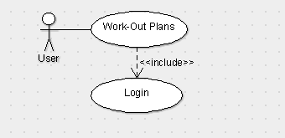

## 4.6 Video Tutorials

4.6.1 *Description and Priority*

*The system will provide a user friendly UI allows the user to view the tutorials which are in the form of videos. user is just able to view the videos and admin can able to change the content or add the contents.As it is an important feature of the web page So, it stands at a priority labelled ‘A’ which means its having a high priority*

4.6.2 Stimulus:

*This specific function is performed by admin as an action an user is able to view This ables to see the video*

Response Sequences:

*It is the function which gives a direct reaction for the user’s action.*

4.6.3 *Functional Requirements*

*REQ-1:A device which is having good Internet connection.*

*REQ-2:The person who logins in is able to access this feature.*

*REQ-3: User must have a supporting browser.*

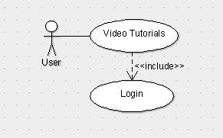

## 4.7 View Responses:

4.7.1 *Description and Priority*

*The system will provide a user friendly UI allows the user to view the responses to the queries which were asked by the user earlier.As it is an important feature of the web page So, it stands at a priority labelled ‘A’ which means its having a high priority .*

4.7.2 Stimulus: *This specific function is performed by admin as an action an user is able to view the responses.*

Response Sequences:*It is the function which gives a direct reaction for the user’s action.*

4.7.3 *Functional Requirements*

*REQ-1:A device which is having good Internet connection.*

*REQ-2:The person who logins in is able to access this feature*

*REQ-3: User must have a supporting browser.*

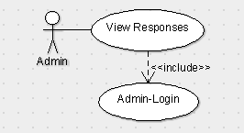

## 4.8 Request Diet Plan:

4.8.1 *Description and Priority*

*The system will provide a user friendly UI allows the user to view the responses to the Diet plan which were requested by the user earlier.As it is an important feature of the web page So, it stands at a priority labelled ‘A’ which means its having a high priority .*

4.8.2 Stimulus

*This specific function is performed by admin as an action an user is able to view the responses*

Response Sequences

*It is the function which gives a direct reaction for the user’s action.*

4.8.3 *Functional Requirements*

*REQ-1:A device which is having good Internet connection.*

*REQ-2:The person who logins in is able to access this feature.*

*REQ-3: User must have a supporting browser.*

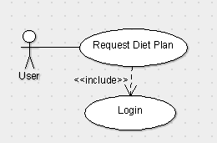

## 4.9 Request Workout Schedules

4.9.1 *Description and Priority*

*The system will provide a user friendly UI allows the user to request the workout schedules which were requested by the user earlier.As it is one of the important feature of the webpage So, it stands at a priority labelled ‘B’ which means its having a high priority .*

4.9.2 Stimulus

*This specific function is performed by admin as an action an user is able to view the responses.*

Response Sequences:

*It is the function which gives a direct reaction for the user’s action.*

4.9.3 *Functional Requirements*

*REQ-1:A device which is having good Internet connection.*

*REQ-2:The person who logins in is able to access this feature.*

*REQ-3: User must have a supporting browser.*

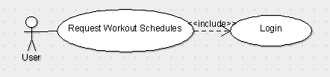

## 4.10Requesting Video Tutorials

4.10.1 *Description and Priority*

*The system will provide a user friendly UI allows the user to request the video tutorial which were requested by the user earlier.As it is one of the important feature of the webpage So, it stands at a priority labelled ‘B’ which means its having a high priority .*

4.10.2 Stimulus

*This specific function is performed by admin as an action an user is able to request the videos.*

Response Sequences

*It is the function which gives a direct reaction for the user’s action.*

4.10.3 *Functional Requirements*

*REQ-1:A device which is having good Internet connection.*

*REQ-2:The person who logins in is able to access this feature.*

*REQ-3: User must have a supporting browser.*

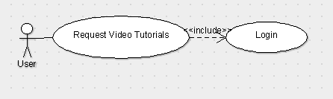

## 4.11Answer Queries

4.11.1 *Description and Priority*

*This is the part performed by the admin and there is no involvement of the user as this is the reply for the questions asked by user earlier.As it is one of the important feature of the webpage So, it stands at a priority labelled ‘B’ which means its having a high priority*

4.11.2 Stimulus

*This specific function is performed by admin as an action an user is able to see the answer for the queries asked by them earlier.*

Response Sequences

*It is the function which takes time to solve the user’s action.*

4.11.3 *Functional Requirements*

*REQ-1:A device which is having good Internet connection.*

*REQ-2:The person who logins in is able to access this feature.*

*REQ-3: User must have a supporting browser.*

*REQ-4:A Valid query should be present.*

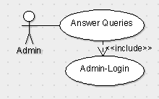

## 4.12 Placing Order

4.12.1 *Description and Priority*

*This is the part performed by the user and there is no involvement of the admin as this is placing order by the user .As it is one of the important feature of the webpage So, it stands at a priority labelled ‘A’ which means its having a high priority*

4.12.2 Stimulus

*This specific function is performed by user, an order is placed by the user itself.*

Response Sequences

*It is the function which gives a direct reaction for the user’s action.*

4.12.3 *Functional Requirements*

*REQ-1:A device which is having good Internet connection.*

*REQ-2:The person who logins in is able to access this feature.*

*REQ-3: User must have a supporting browser*

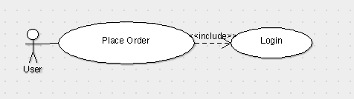

## 4.13Delete the Order

4.13.1 *Description and Priority*

*This is the part performed by the user and there is no involvement of the admin as this is deleting of the order which is placed by the user earlier .As it is one of the important feature of the webpage So, it stands at a priority labelled ‘B’ which means its having a high priority*

4.13.2 Stimulus

*This specific function is performed by user, as the placed order can be deleted by the user.*

Response Sequences

*It is the function which gives a direct reaction for the user’s action.*

4.13.3 *Functional Requirements*

*REQ-1:A device which is having good Internet connection.*

*REQ-2:The person who logins in is able to access this feature.*

*REQ-3: User must have a supporting browser*

*REQ-4: Order should placed earlier.*

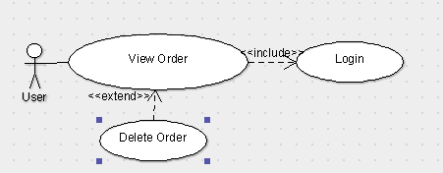

## 4.14 Add WorkOut Schedules

4.14.1 *Description and Priority*

*The system will provide a user friendly UI which is governed by the admin as he is the authority and can add the work out plans .As it is one of the important feature of the webpage So, it stands at a priority labelled ‘A’ which means its having a high priority .*

4.14.2 Stimulus

*This specific function is performed by admin as an action an user is able to view the responses.*

Response Sequences

*It is the function which gives a direct reaction for the user’s action.*

4.14.3 *Functional Requirements*

*REQ-1:A device which is having good Internet connection.*

*REQ-2:The person who logins in is able to access this feature.*

*REQ-3: User must have a supporting browser.*

## 4.15View Order

4.15.1 *Description and Priority*

*This is the part performed by the user and there is no involvement of the admin as this is viewing of the order which is placed by the user earlier .As it is one of the important feature of the webpage So, it stands at a priority labelled ‘B’ which means its having a high priority*

4.15.2 Stimulus

*This specific function is performed by user, as the placed order can be viewed by the user.*

Response Sequences

*It is the function which gives a direct reaction for the user’s action.*

4.15.3 *Functional Requirements*

*REQ-1:A device which is having good Internet connection.*

*REQ-2:The person who logins in is able to access this feature.*

*REQ-3: User must have a supporting browser*

*REQ-4: Order should placed earlier.*

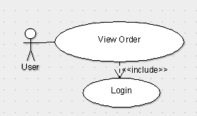

# Other Nonfunctional Requirements

## Performance Requirements

***RESPONSE TIME:****The response time to load the application when the unit is turned on shall be less than 30 seconds. The response time to load the screen based on user’s operations should be less than 5 seconds*

***OPERATION:****The application shall not crash or freeze the system, other than as the result of the operating system error. In such case, the user should again login to the application.*

***SCALING:*** *The system shall scale from 10 – 1000 users*

## Safety Requirements

*If there is extensive damage to a wide portion of the database due to catastrophic failure, such as a disk crash, the recovery method restores a past copy of the database that was backed up to archival storage (typically tape) and reconstructs a more current state by reapplying or redoing the operations.*

## Security Requirements

*Security systems need database storage just like many other applications. However, the special requirements of the security market mean that vendors must choose their database partner carefully.*

## Software Quality Attributes

## *RELIABILITY:This software shall never crash or freeze. The unit shall inform the user to reset the system if major software malfunction has been encounter by the system*

### *AVAILABILITY:The application shall be available to any user who has an internet connection.*

### *SECURITY: The data entered by the user shall be kept secured and private and shall not be disclosed. The application shall be protected against hackers and other malwares. The system shall make use security provided by the web server and database. Firewall and network security are outside the scope of the document.*

### *MAINTAINABILITY:The software should not require any additional maintenance. If any errors occur, the user should be able to logout and login again with his credentials. The system shall be flexible enough to add new modules and upgrade the existing modules.*

### Business Rules

### *Business Rules must be documented. Business Rules must have a unique ID.Business Rules originating from plain text must be documented, pseudo rules and mapped to business rules*

# Other Requirements

*All the required requirements are placed under the respective sub-sections.*

**Appendix A: Glossary**

Admin – Administrator

A -High Priority

B – Low Priority

**Appendix B: Analysis Models**

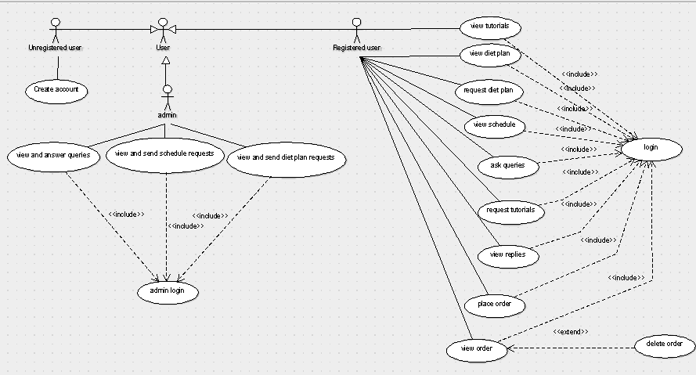

**Appendix C: To Be Determined List**

*There are no list to be determined components as per the design done till the day.*